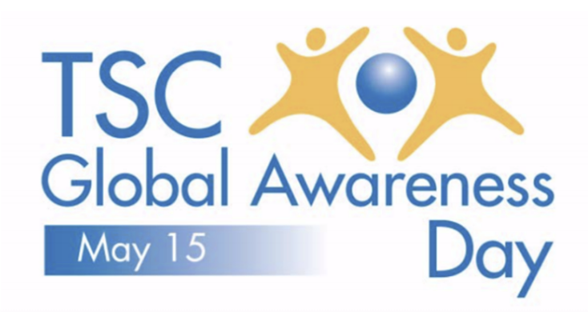
SAMPLE TWEETS

#TSCglobalday May 15 is Tuberous Sclerosis Complex (TSC) Global Awareness Day. TSC is a rare genetic disorder that affects 1 million worldwide. #Unite4TSC and learn more at TSCglobalday.org.

#TSCglobalday May 15 is Tuberous Sclerosis Complex (TSC) Global Awareness Day. TSC is a genetic disorder with no cure that causes non-cancerous tumors to form in vital organs. #Unite4TSC by learning more at TSCglobalday.org.

#TSCglobalday May 15 is Tuberous Sclerosis Complex (TSC) Global Awareness Day. TSC is the leading genetic cause of epilepsy & autism. Seizures occur in about 85% of those with TSC & intellectual disabilities are found in 45-60%. #Unite4TSC by learning more at TSCglobalday.org.

